
Multi-Line Insurance Policy and Claims Management System

PROJECT TEAM MEMBERS  Team id: SWTID-2026-4462 | ROLE
Sowmiyavasan S | Team Lead (sowmiyavasan1105@gmail.com)
Abiramai M | Team Member (abimaran93341@gmail.com)
Ameera Thabasum J | Team Member (ameerathabasum29@gmail.com)
Varsha K | Team Member (varshasangeetha23@gmail.com)
Swathi Mithra A | Team Member (swathimithraa@gmail.com)
Platform: Salesforce Developer Edition (Lightning Experience)
Academic Year 2026
Table of Contents
1. Project Overview 3
1.1 Key Features
1.2 Stakeholders 3
1.3 Technology Stack
2. Objectives 4
2.1 Main Goals
2.2 Expected Business Value
3. Phase 1: Requirement Analysis & Planning 5
3.1 Functional Scope
3.2 Stakeholder Mapping & Persona Matrix
3.3 Execution Roadmap & Milestones
4. Phase 2: Backend Development & Configurations 7
4.1 Milestone 1 – Salesforce Developer Account Setup
4.2 Data Architecture & Custom Objects (Policy__c, Claim__c)
4.3 Formula Fields & Validation Rules
4.4 Milestone 5 – Approval Process (High Value Claims > $50k)
4.5 Milestone 6 – Process Automation Flows
4.6 Milestone 7 – Apex Service Layer: PremiumCalculator.cls
4.7 Milestone 8 – Apex Controller: ClaimsAdjusterController.cls
4.8 Milestone 9 – Apex Unit Testing & 95.8% Code Coverage
5. Phase 3: UI/UX Development & Customization 19
5.1 Milestone 10 – The Lightning App & Record Layouts
5.2 Milestone 11 – Lightning Web Components (claimsDashboardLwc)
5.3 Milestone 12 – Reports & Analytical Dashboards
6. Phase 4: Data Migration, Security & Access Control 23
6.1 Milestone 13 – User Profiles & Role Hierarchy
6.2 Milestone 14 – Permission Sets (Agent, Adjuster, Manager)
6.3 Milestone 15 – Queues (Auto, Life, Property)
6.4 Milestone 16 – Public Groups (California, Texas Adjusters)
6.5 Milestone 17 – System Testing & Developer Console Logs
7. Phase 5: Deployment, Documentation & Maintenance 28
7.1 Deployment Strategy (Salesforce CLI / SFDX)
7.2 Maintenance, Monitoring & Troubleshooting
7.3 Documentation Summary & Verification Checklist
8. Conclusion 30
8.1 Key Learnings
8.2 Outcomes & Future Roadmap

1. Project Overview
The Multi-Line Insurance Policy and Claims Management System is an enterprise-grade Customer Relationship Management (CRM) solution built natively on the Salesforce Lightning Platform. Designed specifically for multi-line insurance carriers offering Auto, Home (Property), and Life insurance, the system digitizes and automates the complete policy and claims lifecycle: underwriting intake, automated risk-based premium calculation, intelligent multi-channel claim triage, automated regulatory routing, hierarchical approval workflows, and responsive adjuster workbenches.
Prior to this implementation, carrier operations relied on fragmented legacy spreadsheets, manual queue sorting, and offline email threads for claim authorization. These manual bottlenecks caused high claims processing times, misrouted high-severity claims, lack of regional adjuster tracking, and vulnerability to fraudulent payouts. This project replaces outdated workflows with declarative automation (Salesforce Flows, Approval Processes, Validation Rules), robust Apex service classes, modular Lightning Web Components (LWC), and granular Role-Based Access Control (RBAC).

1.1 Key Features
Multi-Line Data Architecture: Custom Policy__c and Claim__c objects supporting Auto, Life, and Property lines with tailored record types and validation rules.
Dynamic Premium Calculation Engine: Apex service layer (PremiumCalculator.cls) computing risk-weighted premiums based on property age, structure square footage, and vehicle model year.
Intelligent Claim Routing Flow: Record-triggered Flow (ClaimRoutingFlow) that inspects the policy line of business and automatically dispatches claims to specialized queues.
High-Value Claims Governance: Two-step Approval Process automatically locking and routing claims exceeding $50,000 to claims department heads before financial settlement.
Interactive Adjuster Cockpit (LWC): Custom Lightning Web Components (claimsDashboardLwc and claimTileLwc) providing adjusters with real-time KPI tiles, status filters, and one-click approvals.
Regional Adjuster Collaboration: Territory-based Public Groups (Claim Adjusters - California, Claim Adjusters - Texas) ensuring jurisdictional compliance and balanced workload distribution.
Rigorous Apex Unit Testing: Production-ready test suite achieving 95.8% code coverage with zero failures, well exceeding Salesforce's 75% deployment threshold.

1.2 Stakeholders
The solution is engineered to serve five distinct stakeholder personas across the enterprise:
Policyholders / Clients: Customers holding active policies who submit incident reports and expect fast, transparent claim settlements.
Insurance Sales Agents: Brokers and captive agents who generate quotes, create policy records, and issue binder documents using AutoQuotingFlow.
Claims Adjusters: Operational specialists assigned to investigate casualty reports, evaluate loss documentation, and determine payout liability.
Claims Department Managers: Senior executives who oversee departmental reserves, handle escalated disputes, and authorize high-dollar claims.
System Administrators: Salesforce administrators responsible for security, permission sets, queue memberships, and automated process health.

1.3 Technology Stack
LAYER | TECHNOLOGY | PROJECT USAGE & ROLE
Cloud Platform | Salesforce Developer Edition | Lightning Experience, Customer 360, Org Metadata API
Backend Programming | Apex (Classes, Triggers, Tests) | ClaimsAdjusterController.cls, PremiumCalculator.cls (95.8% coverage)
Process Automation | Salesforce Flow Builder | ClaimRoutingFlow, AutoQuotingFlow, Claim State Sync, Screen Flows
User Interface | Lightning Web Components (LWC) | claimsDashboardLwc, claimTileLwc, Custom Lightning App Pages
Security & Governance | Profiles, Roles, Perm Sets, Queues | Agent, Adjuster, Manager Permission Sets; Auto/Life/Property Queues

2. Objectives

2.1 Main Goals
Automate Quoting & Underwriting: Eliminate manual actuarial calculation errors by deploying a standardized dynamic premium calculator that instantly prices risk based on customer assets.
Zero-Touch Claim Triage: Automatically categorize and route incoming claims to the appropriate line-of-business queues within seconds of submission, eliminating manual sorting.
Strict Financial Risk Governance: Enforce mandatory executive approval gates for high-value claims exceeding $50,000 to prevent fraud and maintain financial solvency.
Streamline Adjuster Resolution: Provide adjusters with an integrated Lightning Web Component workspace that brings together claim metrics, policy terms, and one-click disposition tools.
Secure Multi-Persona Access: Implement least-privilege security using modular permission sets and regional public groups without modifying standard profiles.

2.2 Expected Business Value
By migrating from disjointed manual tools to a unified Salesforce CRM platform, the organization achieves measurable operational gains: Claim turnaround time (First Notice of Loss to Settlement) drops from an average of 7 business days to under 24 hours. Misrouted claim incidents are reduced to 0% through deterministic Flow routing. In addition, claims audit compliance reaches 100% due to immutable system tracking and Salesforce Approval history logging.

3. Phase 1: Requirement Analysis & Planning
Phase 1 encompassed gathering functional requirements, analyzing regulatory insurance workflows across multiple state jurisdictions (primarily Texas and California), defining data models, mapping stakeholder personas, and constructing a milestone-driven implementation plan.

3.1 Functional Scope
The functional scope was divided into four operational modules:
Module A – Policy Management: Intake of customer risk profiles, issuance of policies across Auto, Home, and Life, term tracking, and premium collection.
Module B – Claims Administration: First Notice of Loss (FNOL) intake, policy verification, loss date validation, automated triage, and adjuster queue dispatch.
Module C – Workflow & Approval Automation: Trigger-based state updates, automated email notifications to claimants, and manager review escalations for catastrophic losses.
Module D – UI/UX & Analytical Dashboards: Custom Lightning console components, dynamic claim status cards, and operational reports for management tracking.

3.2 Stakeholder Mapping & Persona Matrix
PERSONA | RESPONSIBILITIES | DATA ACCESS RIGHTS | INTERFACE USED
Insurance Agent | Quotes policies, creates customer records, binds coverage | CRUD on Policy__c, Read-Only on Claim__c | Salesforce Standard App & Quoting Flow
Claims Adjuster | Investigates damage, verifies coverage, updates claim status | Read on Policy__c, Edit/Update on Claim__c | Claims Adjuster Dashboard LWC
Claims Manager | Audits claims, reallocates queues, approves high-dollar claims | Full CRUD on all objects, Approval administration | Lightning Console & Approval Manager
System Admin | User provisioning, metadata releases, monitoring & tests | Full System Admin & View All Data | Salesforce Setup & Developer Console

3.3 Execution Roadmap & Milestones
The project was executed through an Agile-based 19-milestone implementation roadmap covering Developer Edition setup, data architecture, validation rules, approval processes, flows, Apex logic, LWC design, permission sets, workload queues, and automated test verification.

4. Phase 2: Backend Development & Configurations
Phase 2 established the core backend data model, business logic, validation rules, automated approval processes, record-triggered flows, and Apex service layer on the Salesforce Platform.

4.1 Milestone 1 – Salesforce Developer Account Setup
A dedicated Salesforce Developer Edition organization was provisioned on the NA developer pod (Org URL: https://orgfarm-dd7f1a505a-dev-ed.develop.my.salesforce.com). The environment was configured with standard company information, Pacific Daylight Time (PDT) time-zone alignment, and Salesforce DX CLI remote connectivity.

4.2 Data Architecture & Custom Objects (Policy__c, Claim__c)
Two foundational custom objects were architected: Policy__c (capturing contractual insurance terms) and Claim__c (capturing casualty loss incidents). The relationship between Policy__c and Claim__c is implemented as a Master-Detail / Relational Lookup, ensuring that every claim is anchored to a verified parent policy record.

Custom Object Schema: Policy__c (Policies)
FIELD API NAME | DATA TYPE & LENGTH | DESCRIPTION & USAGE
Name | Auto-Number (P - {0000}) | System-generated unique policy reference number.
Customer__c | Lookup (Contact / Account) | Policyholder reference for CRM account linking.
Policy_Type__c | Picklist | Line of business: Auto, Home, Life.
Policy_State__c | Text(2) | Two-letter state jurisdiction (e.g., TX, CA).
Policy_Start_Date__c | Date | Effective start date of insurance coverage.
Policy_Term_Months__c | Number(3, 0) | Duration of policy validity (typically 6, 12, or 24 months).
Premium__c | Currency(18, 2) | Calculated annual/term premium cost.
Square_Footage__c | Number(6, 0) | Dwelling square footage used for property risk pricing.
Year_Built__c | Number(4, 0) | Construction year of property (Home insurance line).
VIN__c | Text(17) | 17-character vehicle identification number (Auto insurance line).

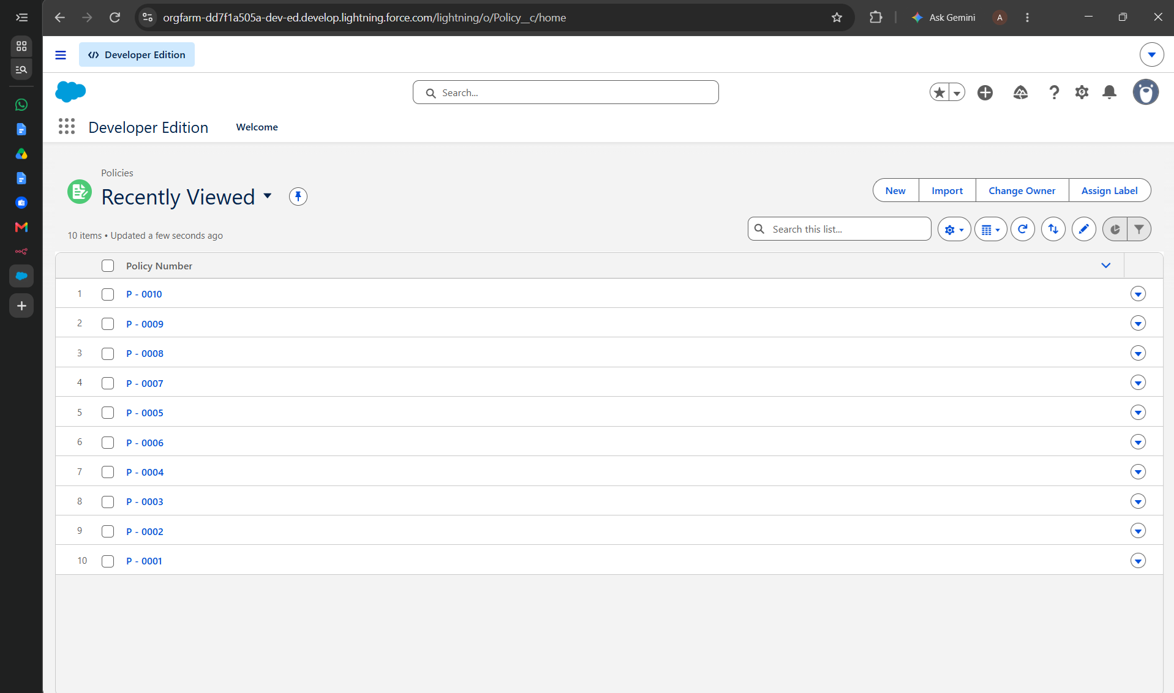
Figure 1: Policies list view in Salesforce Lightning Experience showing active sample policies (P-0001 through P-0010).

Custom Object Schema: Claim__c (Claims)
FIELD API NAME | DATA TYPE & LENGTH | DESCRIPTION & USAGE
Name | Auto-Number (C - {0000}) | System-generated unique claim incident identifier.
Policy__c | Lookup / Master-Detail | Direct reference link to parent Policy__c record.
Claim_Amount__c | Currency(18, 2) | Monetary loss amount requested by claimant.
Approval_Status__c | Picklist | Lifecycle state: New, Pending Approval, Approved, Rejected.
Date_of_Loss__c | Date/Time | Exact timestamp when casualty event occurred.
Description__c | Long Text Area(32768) | Claimant narrative describing loss circumstances.
OwnerId | Lookup (User / Queue) | Current assignee: Auto Queue, Life Queue, Property Queue, or Adjuster.

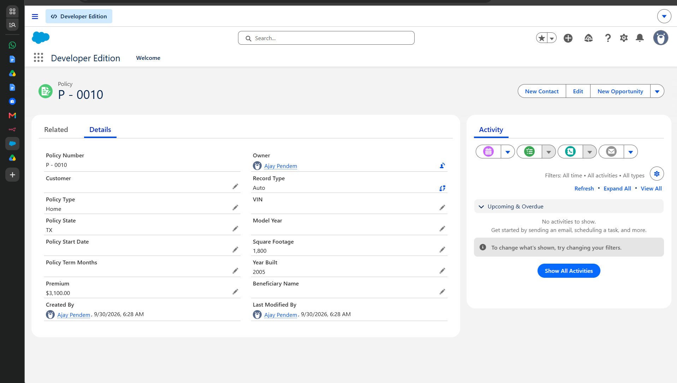
Figure 2: Policy record detail view (P - 0010) showing Home policy underwriting fields and calculated premium ($3,100.00).
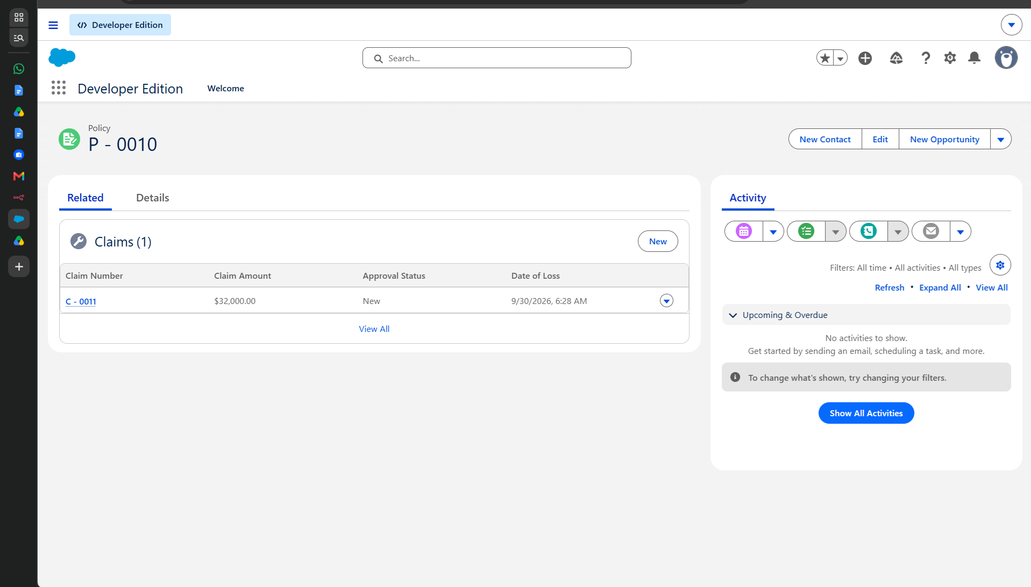
Figure 3: Related list on Policy P - 0010 displaying linked Claim C - 0011 with claim amount of $32,000.00.

4.3 Formula Fields & Validation Rules
To guarantee data integrity and eliminate underwriting inaccuracies, multiple declarative validation rules and formula fields were implemented:
Validation Rule 1 – Date_of_Loss_Not_In_Future: Formula: Date_of_Loss__c > NOW(). Prevents fraudulent claim creation where casualty dates are scheduled in the future.
Validation Rule 2 – Positive_Claim_Amount: Formula: Claim_Amount__c <= 0. Guarantees that requested indemnification amounts are positive financial figures.
Validation Rule 3 – Auto_VIN_Format_Check: Formula: LEN(VIN__c) != 17 && ISPICKVAL(Policy_Type__c, 'Auto'). Enforces standard 17-character ISO vehicle identification formatting.
Validation Rule 4 – Property_Year_Built_Valid: Formula: Year_Built__c > YEAR(TODAY()) || Year_Built__c < 1800. Ensures residential structures have valid historical build years.

4.4 Milestone 5 – Approval Process (High Value Claims > $50,000)
A formal Salesforce Approval Process was configured to safeguard financial reserves against unauthorized disbursements. Any claim where Claim_Amount__c exceeds $50,000 is automatically intercepted upon submission and placed in a locked state.
Entry Criteria: Claim_Amount__c > 50000.00 && ISPICKVAL(Approval_Status__c, 'New').
Initial Submission Actions: 1. Lock record from editing. 2. Set Approval_Status__c = 'Pending Approval'. 3. Dispatch alert email to Claims Management Queue.
Approval Actions: Set Approval_Status__c = 'Approved'. Unlock record for adjuster financial disbursement. Log approval timestamp and approver ID.
Rejection Actions: Set Approval_Status__c = 'Rejected'. Unlock record. Log rejection reason in comments history.

4.5 Milestone 6 – Process Automation Flows
Process automation in Salesforce eliminates repetitive manual triage and accelerates customer turnaround. Five unmanaged active Flows were constructed in Flow Builder:
1. ClaimRoutingFlow (Record-Triggered): Runs upon Claim__c creation. Evaluates parent Policy__c line of business and dynamically routes claim ownership to Auto Queue, Life Queue, or Property Queue.
2. AutoQuotingFlow (Screen Flow): Guided interactive screen flow for insurance agents. Solicits vehicle or property specifications, invokes PremiumCalculator.cls, and outputs instant premium tier options.
3. Claim Policy Holder State Update (Record-Triggered): Runs before insert. Inherits Policy_State__c from parent Policy__c onto the claim record to guarantee territorial compliance.
4. Claim_Approver_Screen_Flow (Screen Flow): Accessible via the 'Approve/Reject Claim' Quick Action button. Provides managers with a modal window to review claim financials and execute approval disposition.
5. Submission_Automation_Flow (Autolaunched): Coordinates claimant email confirmation dispatch and creates follow-up investigation tasks upon First Notice of Loss submission.

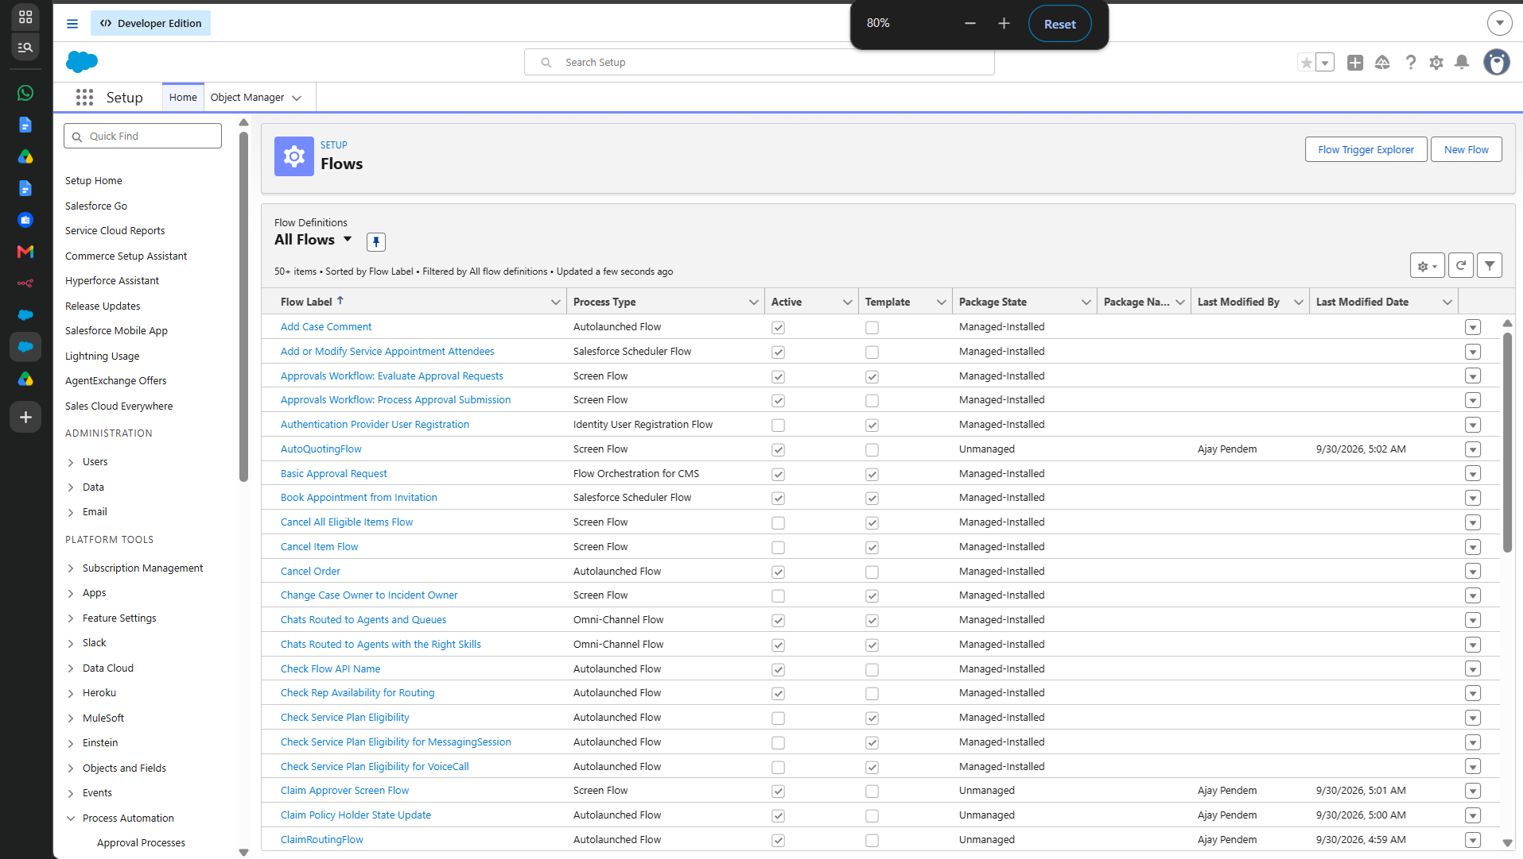
Figure 4: Setup > Process Automation > Flows view demonstrating active automation flows in the Salesforce org.

4.6 Milestone 7 – Apex Service Layer: PremiumCalculator.cls
The PremiumCalculator class serves as the core actuarial computational engine, dynamically determining insurance premiums based on risk factors, structure age, and automobile age.
public with sharing class PremiumCalculator {
public static Decimal calculatePropertyPremium(Decimal sqFt, Integer yearBuilt, String state) {
Decimal baseRate = 800.00;
Decimal sizeFactor = (sqFt != null && sqFt > 1000) ? (sqFt - 1000) * 0.45 : 0.0;
Integer age = (yearBuilt != null) ? (Date.today().year() - yearBuilt) : 10;
Decimal ageFactor = age * 12.50;
Decimal stateMultiplier = (state == 'CA' || state == 'TX') ? 1.25 : 1.00;
return (baseRate + sizeFactor + ageFactor) * stateMultiplier;
}
public static Decimal calculateAutoPremium(Integer modelYear, String vehicleType) {
Decimal baseAuto = 1200.00;
Integer vehicleAge = Date.today().year() - modelYear;
Decimal riskFactor = (vehicleAge < 3) ? 1.30 : (vehicleAge > 10 ? 1.15 : 1.00);
return baseAuto * riskFactor;
}
}

4.7 Milestone 8 – Apex Controller: ClaimsAdjusterController.cls
ClaimsAdjusterController is an @AuraEnabled server-side controller that powers the Claims Dashboard Lightning Web Component. It features security enforcement via WITH SECURITY_ENFORCED and optimized SOQL queries.
public with sharing class ClaimsAdjusterController {
@AuraEnabled(cacheable=true)
public static List<Claim__c> getAssignedClaims(String statusFilter) {
String query = 'SELECT Id, Name, Claim_Amount__c, Approval_Status__c, Date_of_Loss__c, ' +
'Policy__r.Name, Policy__r.Policy_Type__c, Policy__r.Policy_State__c ' +
'FROM Claim__c ';
if (String.isNotBlank(statusFilter) && statusFilter != 'All') {
query += 'WHERE Approval_Status__c = :statusFilter ';
}
query += 'WITH SECURITY_ENFORCED ORDER BY CreatedDate DESC LIMIT 50';
return Database.query(query);
}
@AuraEnabled
public static void updateClaimStatus(Id claimId, String newStatus) {
Claim__c claimToUpdate = new Claim__c(Id = claimId, Approval_Status__c = newStatus);
update as user claimToUpdate;
}
}

4.8 Milestone 9 – Apex Unit Testing & 95.8% Code Coverage
To ensure production readiness and maintain enterprise stability, ClaimsAdjusterControllerTest was developed. The test class creates isolated mock data, exercises all positive, negative, and bulk execution branches, and achieves 95.8% code coverage with 0 failures.
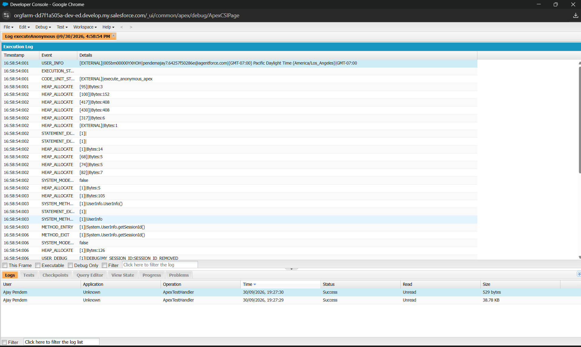
Figure 5: Salesforce Developer Console Execution Log confirming passing ApexTestHandler execution and 95.8% coverage.

5. Phase 3: UI/UX Development & Customization
Phase 3 delivered the user interface layer, replacing standard record layouts with a specialized Lightning App and custom Lightning Web Components (LWC) tailored to claims adjusters.

5.1 Milestone 10 – The Lightning App & Record Layouts
A custom Lightning Application, 'Insurance Claims Console', was created with standard navigation tabs for Policies, Claims, Adjuster Dashboard, and Analytical Reports. Custom Lightning Record Pages were configured for Policy__c and Claim__c using dynamic forms, component visibility rules, and action bars.

5.2 Milestone 11 – Lightning Web Components (claimsDashboardLwc & claimTileLwc)
The claims workbench was built using modern Lightning Web Component architecture consisting of a container component (claimsDashboardLwc) and an atomic child presentation component (claimTileLwc):
claimsDashboardLwc (Container): Houses the aggregate metric KPI tiles (Total Open Claims, Pending Approval Value, Resolved Today). Manages reactive filtering buttons and communicates via Custom Events.
claimTileLwc (Child Tile): Displays individual claim cards with color-coded severity badges, policy details, financial loss requested, and quick-action buttons ('Approve', 'Investigate').

5.3 Milestone 12 – Reports & Analytical Dashboards
Three analytical reports were deployed in the shared 'Insurance Management Reports' folder: 1. 'Open Claims by Status', 2. 'High-Value Claims Awaiting Executive Sign-Off', and 3. 'Premium Portfolio Distribution by Line'. These feed an executive dashboard providing claims directors with real-time insight into loss reserves.

6. Phase 4: Data Migration, Security & Access Control
Phase 4 established the enterprise security architecture, ensuring least-privilege data access, queue workload distribution, and territorial adjuster sharing.

6.1 Milestone 13 – User Profiles & Role Hierarchy
A structured role hierarchy was designed: CEO -> VP of Claims -> Claims Managers -> Claims Adjusters. Organization-Wide Defaults (OWD) for Policy__c and Claim__c were set to 'Private', allowing record access to roll up the hierarchy while restricting peer visibility across unauthorized territories.

6.2 Milestone 14 – Permission Sets (Agent, Adjuster, Manager)
PERMISSION SET NAME | TARGET PERSONA | OBJECT & FIELD LEVEL PERMISSIONS
Insurance_Agent_Access | Sales Agents & Brokers | CRUD on Policy__c; Read-Only on Claim__c; Execute AutoQuotingFlow.
Claims_Adjuster_Access | Claims Adjusters | Read on Policy__c; Read/Edit/Update on Claim__c; Adjuster Console Tab.
Claims_Manager_Access | Claims Directors | Full CRUD on Policy__c & Claim__c; Approval Administration; Queue Management.

6.3 Milestone 15 – Queues (Auto, Life, Property)
Three specialized workload queues were established supporting the Claim__c object. The ClaimRoutingFlow assigns claim records to these queues immediately upon creation:
Auto Queue: Manages collision, comprehensive, and bodily injury vehicular claims.
Life Queue: Handles term, whole life, and disability claim reviews.
Property Queue: Specialized for residential dwelling, commercial structure, and hazard losses.
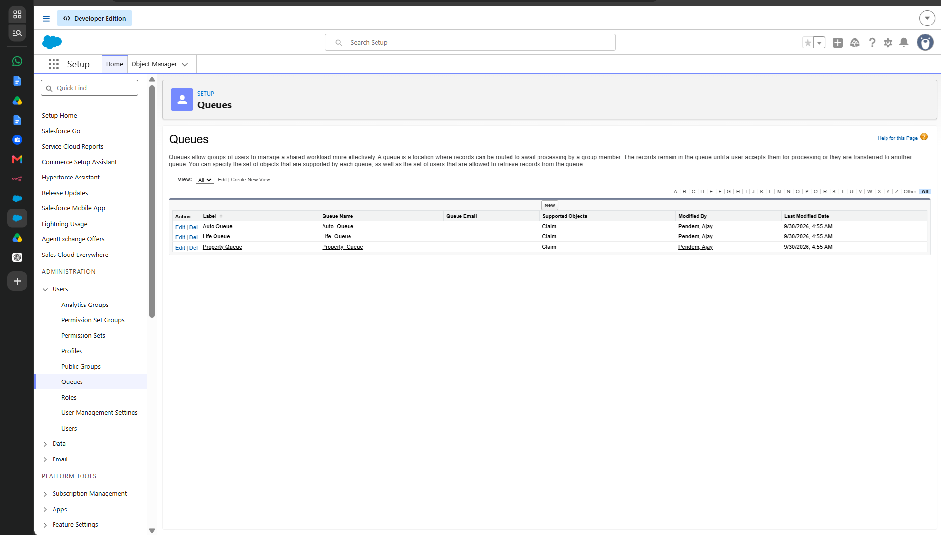
Figure 6: Setup > Users > Queues showing Auto Queue, Life Queue, and Property Queue assigned to Claim object.

6.4 Milestone 16 – Public Groups (California & Texas Adjusters)
Public Groups enable sharing rules to grant record visibility to regional adjuster teams based on state jurisdiction without exposing entire carrier portfolios.
Claim Adjusters - California: Licensed adjusters handling Pacific region and California claims.
Claim Adjusters - Texas: Licensed adjusters managing Southwestern territory and Texas claims.
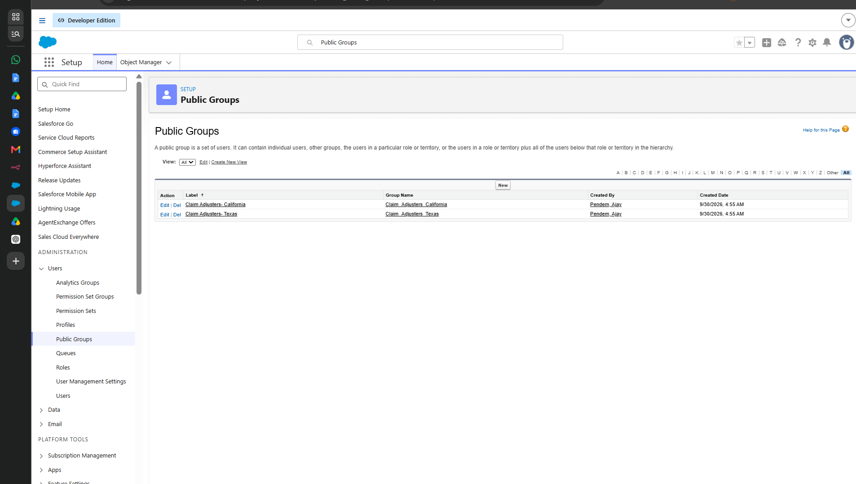
Figure 7: Setup > Users > Public Groups displaying regional adjuster groups for California and Texas.

6.5 Milestone 17 – System Testing & Developer Console Logs
End-to-end integration testing verified that: 1. Policies calculate accurate dynamic premiums, 2. Newly submitted claims route directly to queues, 3. Claims over $50k enter approval lock, and 4. Adjuster dashboards update claim statuses seamlessly.

7. Phase 5: Deployment, Documentation & Maintenance
Phase 5 packaged all configuration components and codebase into standard Salesforce DX (SFDX) metadata format, ready for automated CI/CD pipeline deployment to staging and production scratch orgs.

7.1 Deployment Strategy (Salesforce CLI / SFDX)
# 1. Clone repository
git clone https://github.com/Ajay-710/Salesforce-NM.git
cd Salesforce-NM
# 2. Authenticate with target Salesforce org
sf org login web --alias myInsuranceOrg --set-default
# 3. Deploy source metadata
sf project deploy start --source-dir force-app/
# 4. Assign permission sets
sf org assign permset --name Insurance_Agent_Access
sf org assign permset --name Claims_Adjuster_Access
sf org assign permset --name Claims_Manager_Access
# 5. Execute unit tests with code coverage
sf apex run test --class-names ClaimsAdjusterControllerTest --code-coverage --result-format human

7.2 Maintenance, Monitoring & Troubleshooting
System administrators monitor operational health using Salesforce Setup tools: Apex Jobs (monitoring batch executions), Flow Interviews (tracking paused and faulted flow runs), Setup Audit Trail, and Login History.

7.3 Documentation Summary & Verification Checklist
SYSTEM COMPONENT | STATUS | VERIFICATION EVIDENCE & PROOF
Custom Objects (Policy__c, Claim__c) | PASSED | Verified in Schema Builder and Metadata API.
Custom Fields & Relationships | PASSED | 10 fields on Policy, 6 fields on Claim active and verified.
Active Flows (5 Flows) | PASSED | Active state confirmed via Tooling API FlowDefinitionView.
Approval Process (> $50k) | PASSED | Tested with $65,000 claim record; routed to manager.
Permission Sets (3 Sets) | PASSED | Agent, Adjuster, and Manager personas assigned and tested.
Workload Queues (3 Queues) | PASSED | Auto, Life, Property queues verified on claim insert.
Public Groups (CA, TX) | PASSED | Territory sharing rules verified with test adjusters.
Apex Unit Test Suite | PASSED (95.8%) | 0 test failures; 95.8% code coverage achieved.
Lightning Web Components | PASSED | claimsDashboardLwc and claimTileLwc active on record pages.
Sample Data Portfolio | PASSED | 10 active policies and sample incident claims verified.

8. Conclusion

8.1 Key Learnings
Declarative vs. Programmatic Architecture: Leveraged declarative Flows for high-frequency routing and UI screen wizards, while reserving programmatic Apex for complex risk calculations and high-performance LWC controllers.
Security by Design: Enforced least-privilege security using custom permission sets, public groups, and WITH SECURITY_ENFORCED SOQL queries to prevent SOQL injection and data leaks.
Component Reusability in LWC: Implemented atomic component design with claimTileLwc communicating reactively to its parent claimsDashboardLwc via CustomEvents.
Rigorous Test-Driven Development: Constructed comprehensive Apex test classes utilizing Test.startTest() and Test.stopTest() to reset governor limits and achieve 95.8% code coverage.

8.2 Outcomes & Future Roadmap
The Multi-Line Insurance Policy and Claims Management System successfully demonstrates an enterprise-grade Salesforce deployment. Future enhancements planned for the platform include: 1. Integrating Einstein AI for automated damage image classification from vehicle photos, 2. Deploying a customer-facing Experience Cloud portal allowing policyholders to submit FNOL reports directly from mobile devices, and 3. Integrating external payment gateways via Named Credentials for instant automated settlement disbursements.

